**运行代码**

#include <iostream>

using namespace std;

class Base {

public:

void setx(int i)

{

x = i;

}

int getx()

{

return x;

}

private:

int x;

};

class Derived :public Base {

public:

void sety(int i)

{

y = i;

}

int gety()

{

return y;

}

void show()

{

cout << "Base::x=" << x << endl;

}

public:

int y;

};

int main()

{

Derived bb;

bb.setx(16);

bb.sety(25);

bb.show();

cout << "Base::x=" << bb.x << endl;

cout << "Derived::y=" << bb.y << endl;

cout << "Base::x=" << bb.getx() << endl;

cout << "Derived::y=" << bb.gety() << endl;

return 0;

}

**运行结果**

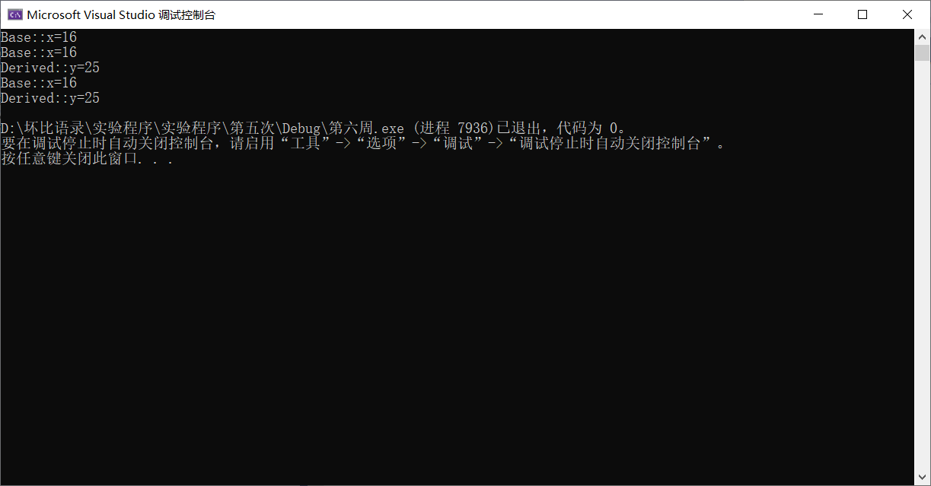

**感想和心得**

**了解了继承下的构造函数与析构函数，本次上机实验的目的是掌握派生类的声明方法和派生类构造函数的定义方法、掌握不同方式下，构造函数与析构函数的执行顺序与构造规则。**

**实验复杂，不怎么会写了，有点麻烦的实验就很难写对，写完整，需要多次修改。**